Force Gauge
# Source: AI Source: Provided by: [Data Path: Persons Table -> ID Column: 1, Name_En Column: Motasem Essam] -> From: [ChatGPT] on [7/17/2026]
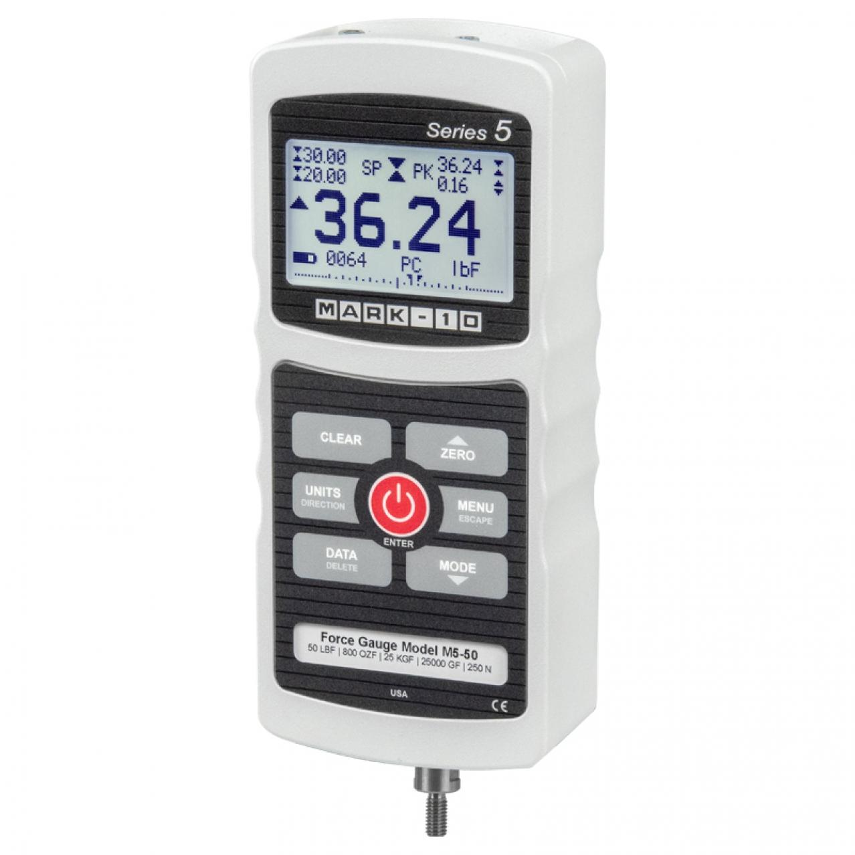
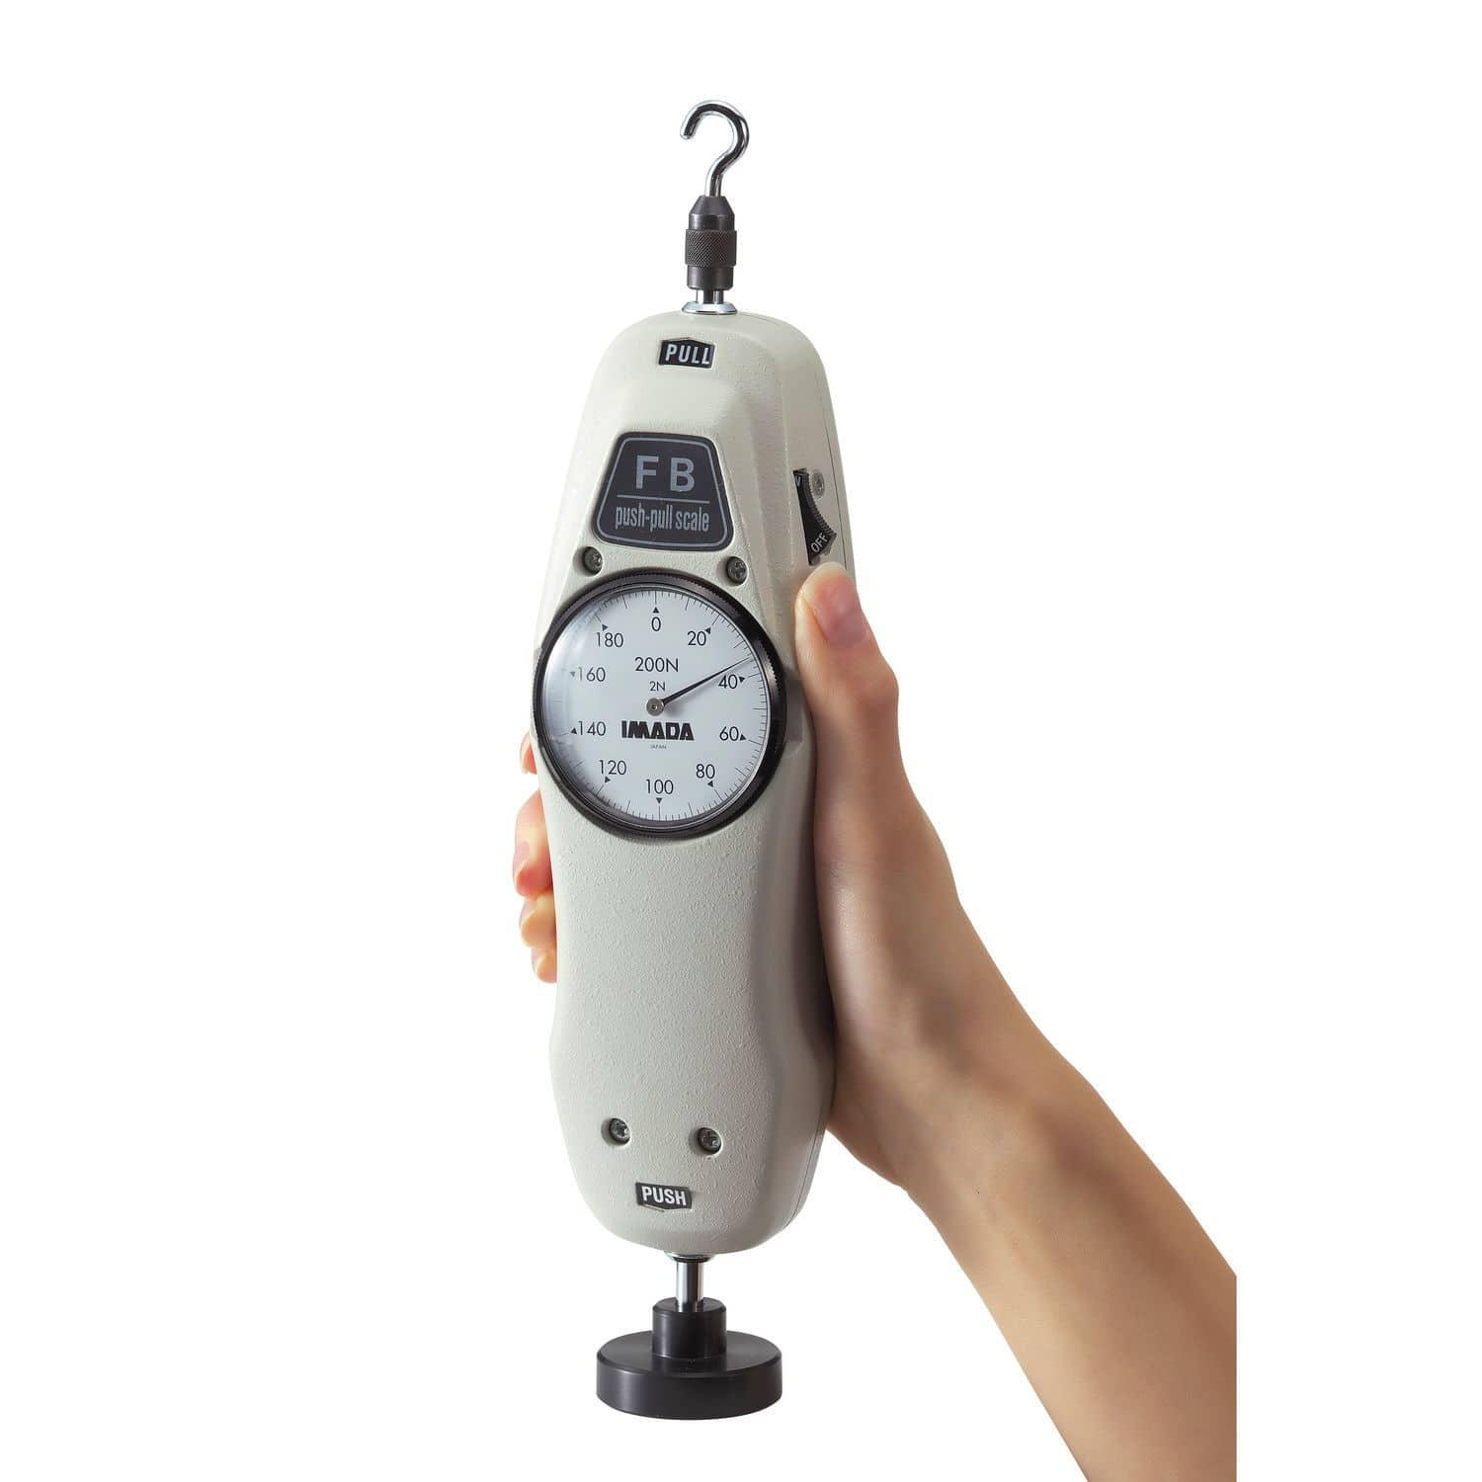
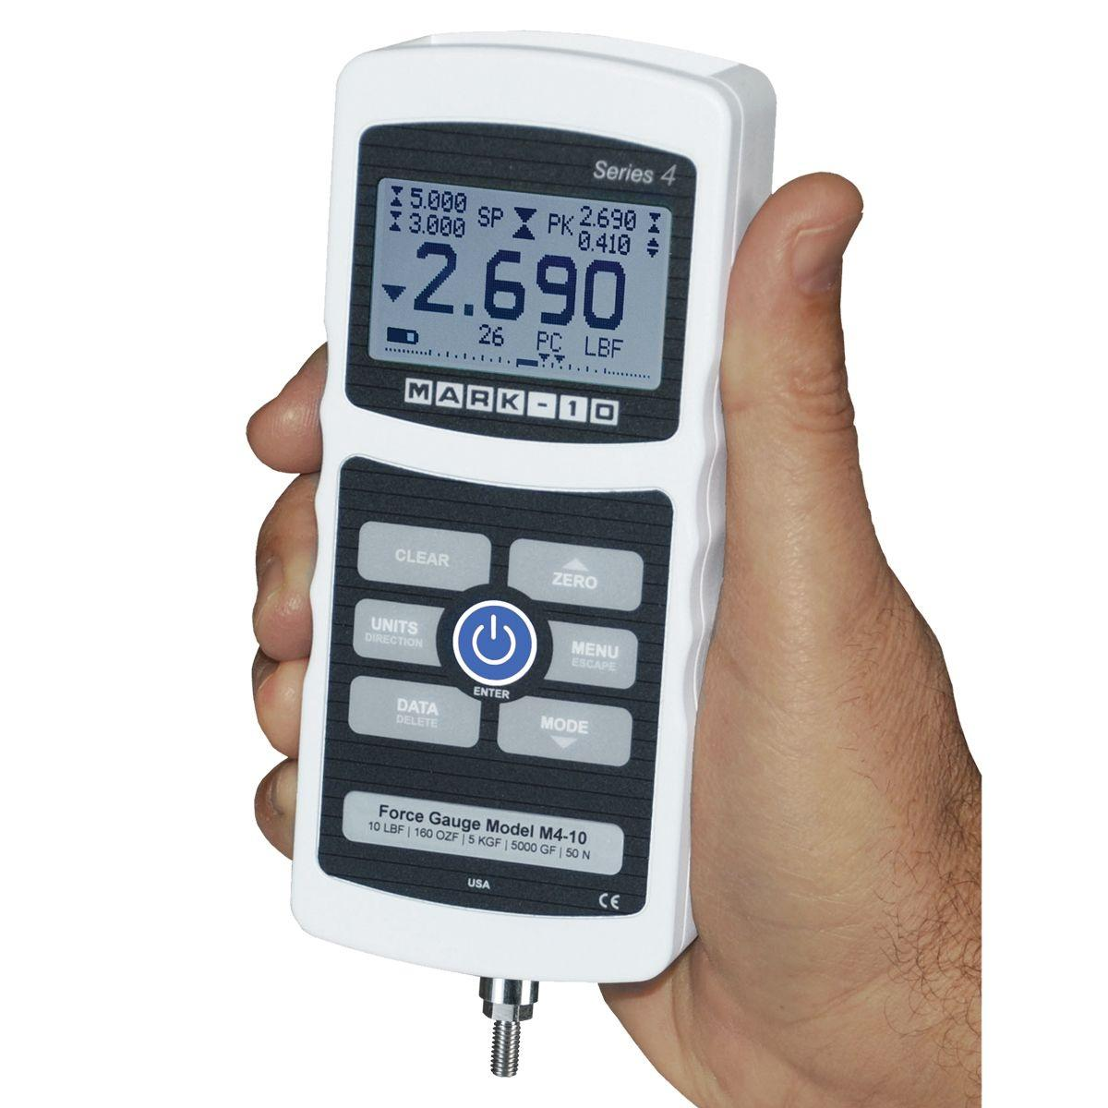
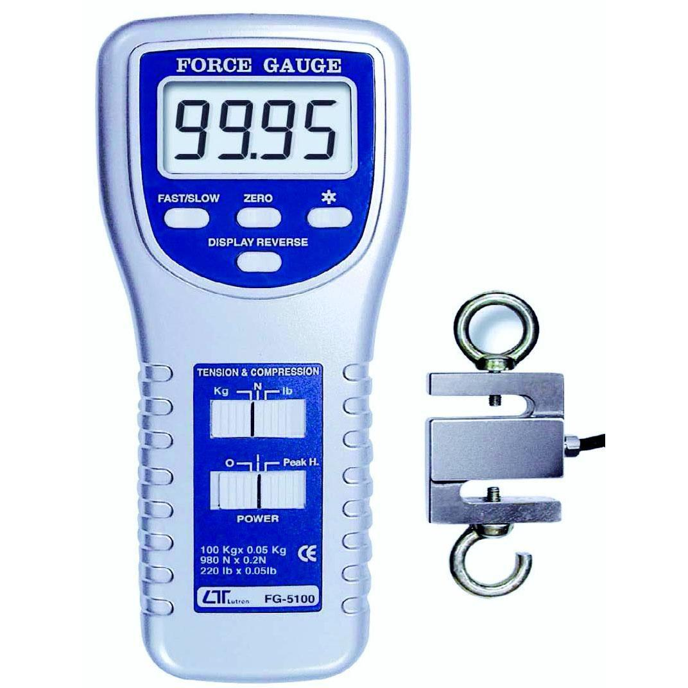
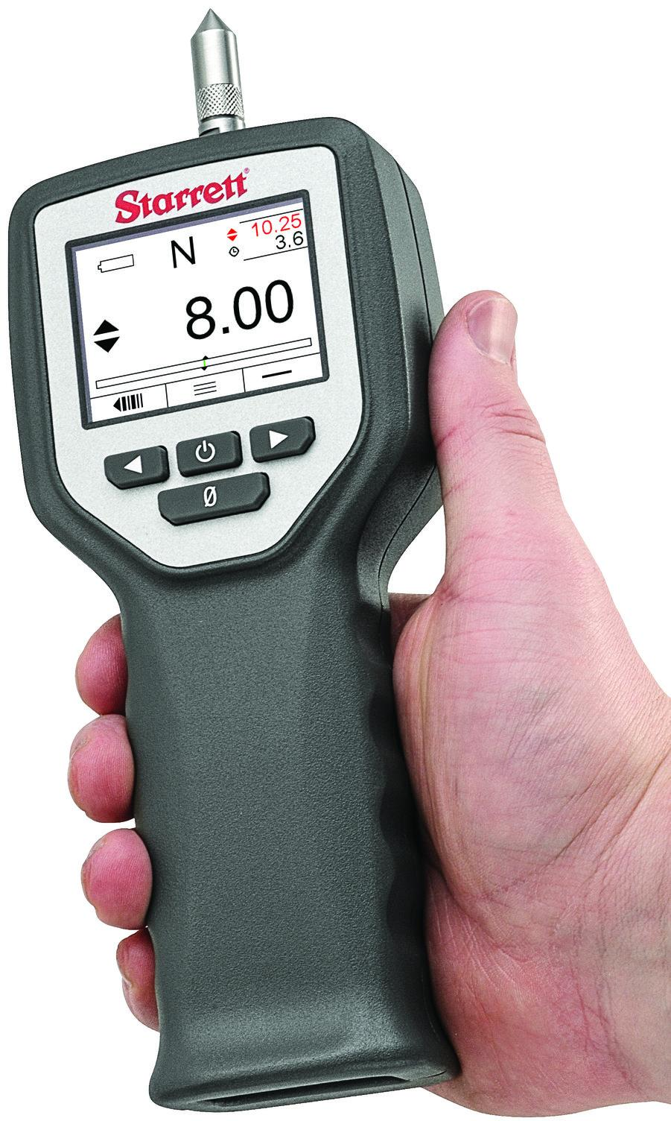
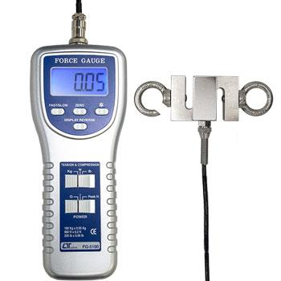
A Force Gauge is a measuring instrument used to determine the magnitude of push (compression) or pull (tension) forces. It is widely used in laboratories, manufacturing, quality control, product testing, ergonomics, and mechanical engineering to measure force accurately.
Force gauges are available in mechanical, digital, hydraulic, and high-capacity designs.

Definition
# Source: AI Source: Provided by: [Data Path: Persons Table -> ID Column: 1, Name_En Column: Motasem Essam] -> From: [ChatGPT] on [7/17/2026]
A Force Gauge is an instrument designed to measure the magnitude of an applied force in tension or compression.

Purpose
# Source: AI Source: Provided by: [Data Path: Persons Table -> ID Column: 1, Name_En Column: Motasem Essam] -> From: [ChatGPT] on [7/17/2026]
A force gauge is used to:
- Measure pulling force.
- Measure pushing force.
- Test product strength.
- Verify spring forces.
- Perform quality control.
- Measure grip and operating forces.

Principle of Operation
# Source: AI Source: Provided by: [Data Path: Persons Table -> ID Column: 1, Name_En Column: Motasem Essam] -> From: [ChatGPT] on [7/17/2026]
The applied force deforms an internal sensing element.
- Mechanical gauges use a calibrated spring.
- Digital gauges use a strain-gauge load cell.
- Hydraulic gauges convert force into hydraulic pressure.
The deformation or pressure is converted into a force value displayed on the scale or screen.

Main Components
# Source: AI Source: Provided by: [Data Path: Persons Table -> ID Column: 1, Name_En Column: Motasem Essam] -> From: [ChatGPT] on [7/17/2026]
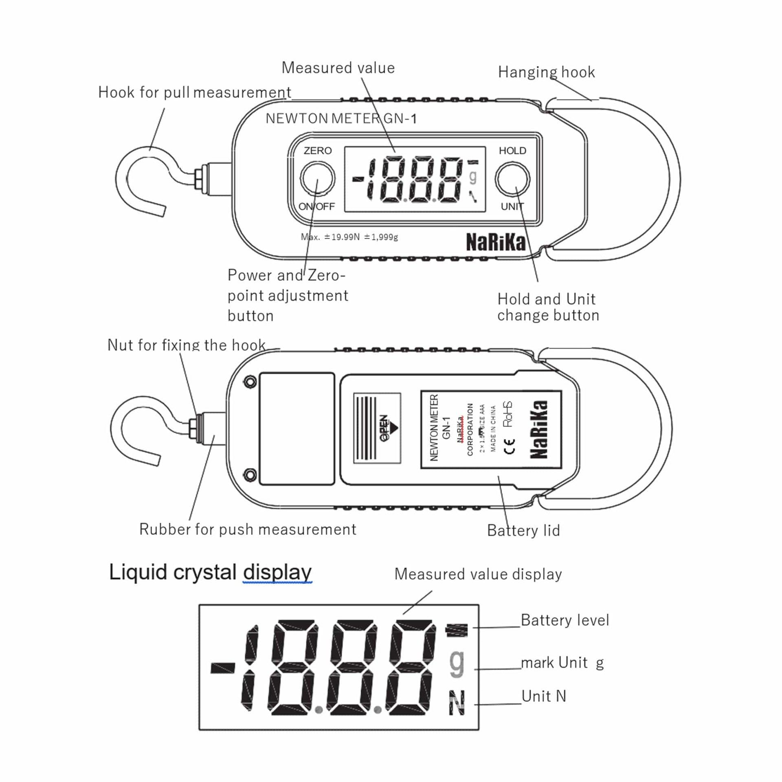
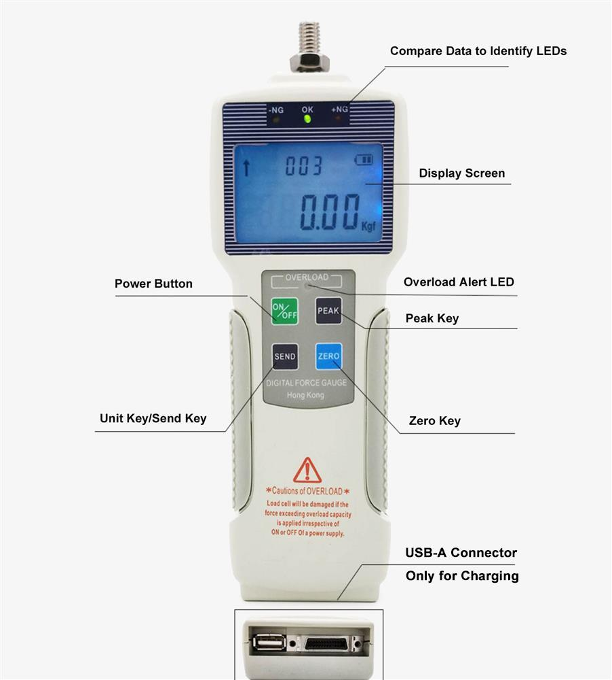
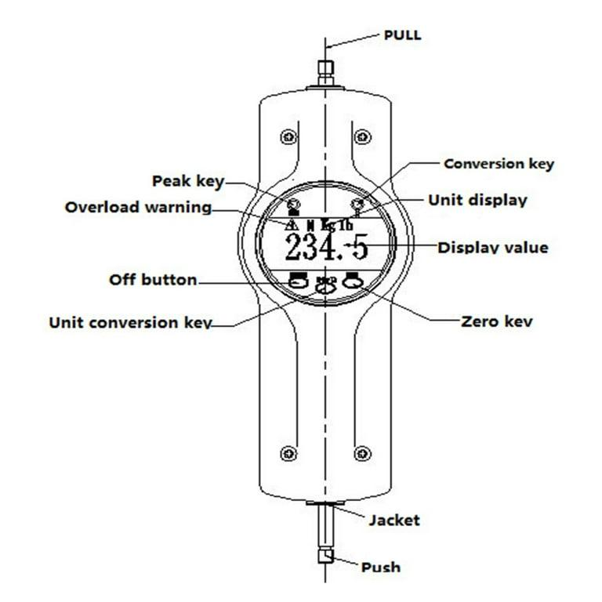
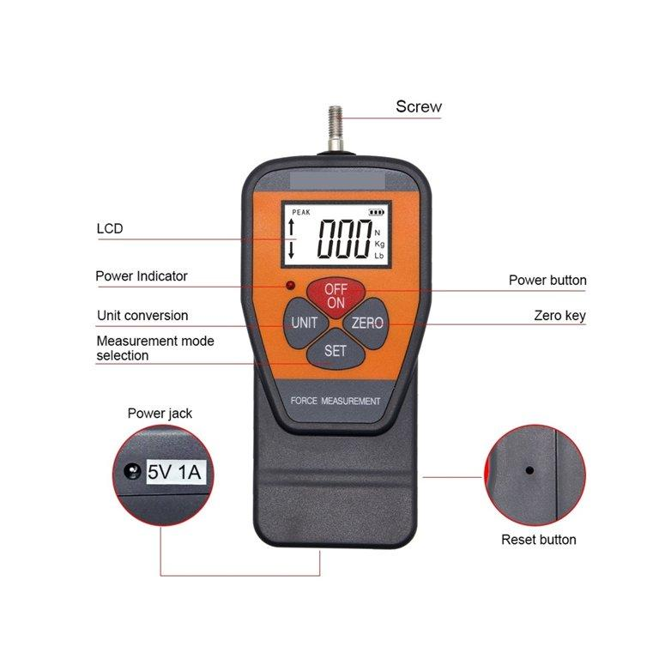

A typical force gauge consists of:
- Force sensing element (spring, load cell, or hydraulic piston)
- Display (analog dial or digital)
- Hook or attachment fixture
- Housing
- Control buttons (digital models)
- Battery (digital models)

Types of Force Gauges

1. Mechanical Force Gauge
# Source: AI Source: Provided by: [Data Path: Persons Table -> ID Column: 1, Name_En Column: Motasem Essam] -> From: [ChatGPT] on [7/17/2026]
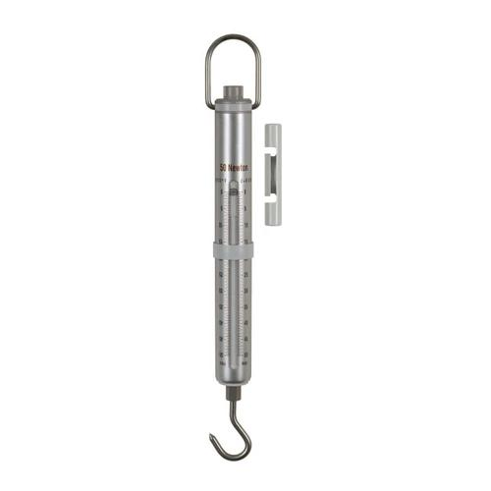
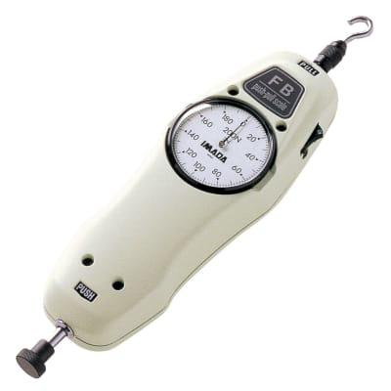
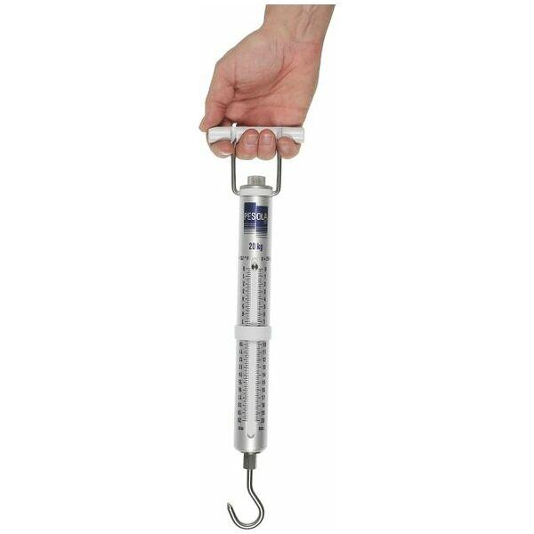
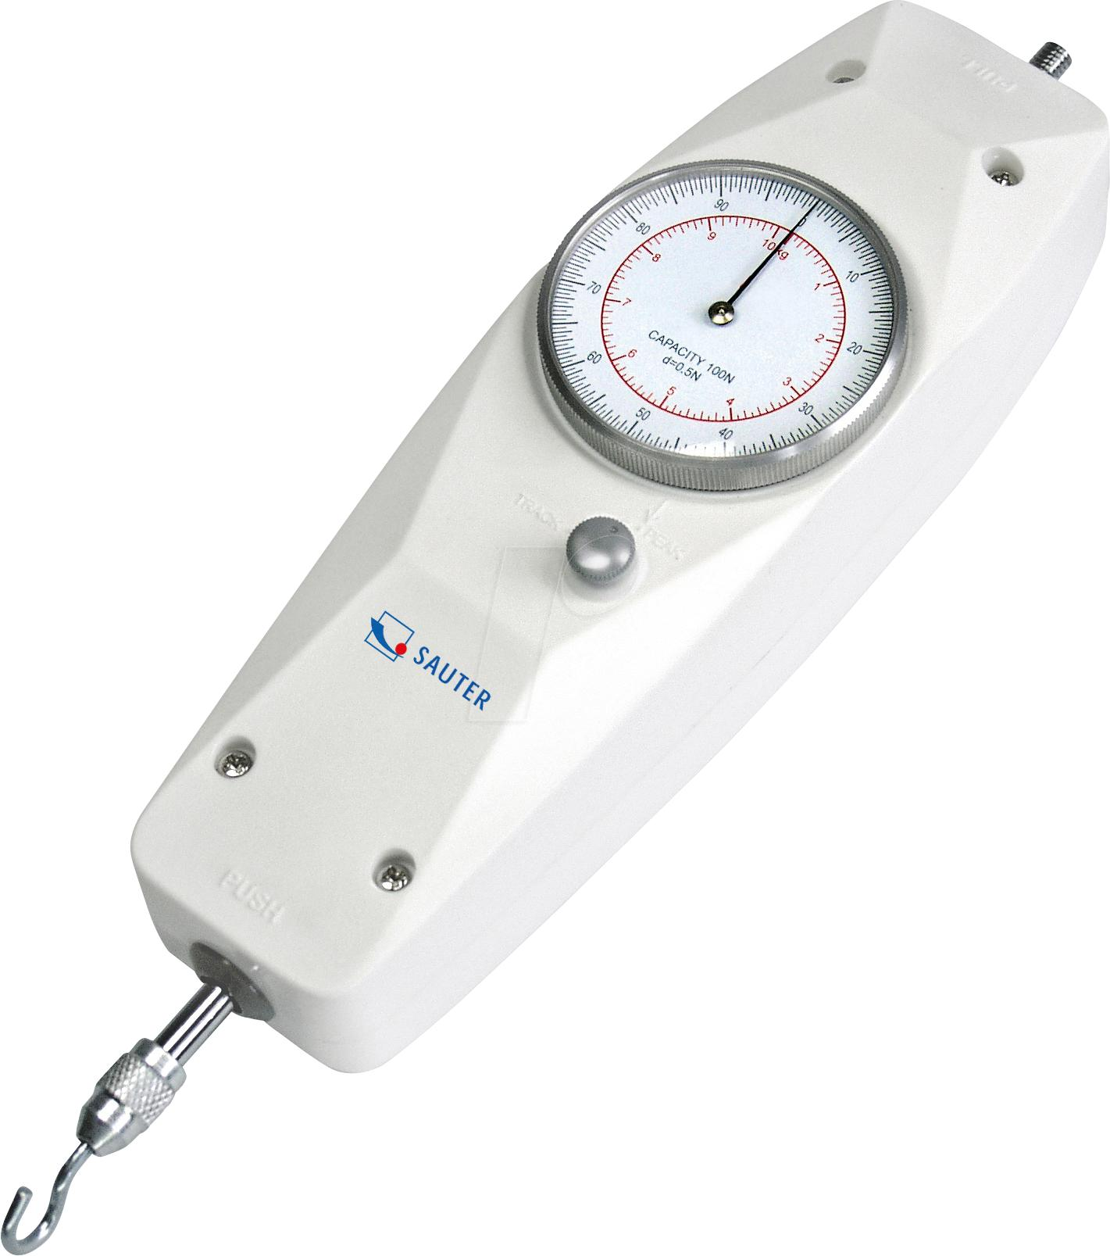
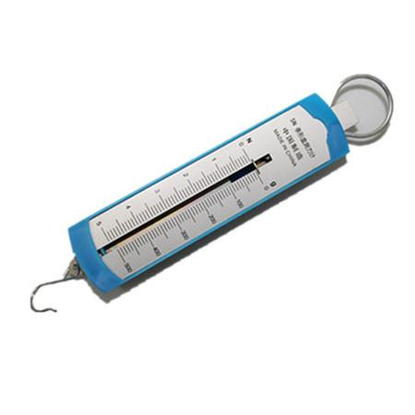
Description
Uses a calibrated spring mechanism to measure force and display the result on an analog dial.
Features
- No batteries required
- Simple construction
- Durable
- Low maintenance
Applications
- Education
- Workshops
- General mechanical testing

2. Digital Force Gauge
# Source: AI Source: Provided by: [Data Path: Persons Table -> ID Column: 1, Name_En Column: Motasem Essam] -> From: [ChatGPT] on [7/17/2026]
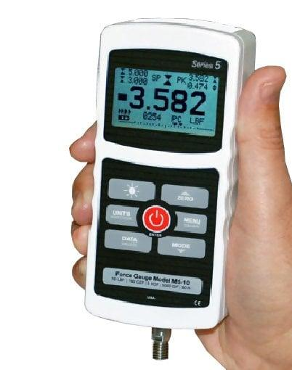
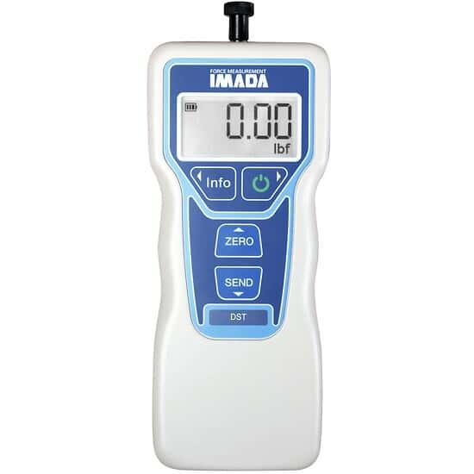
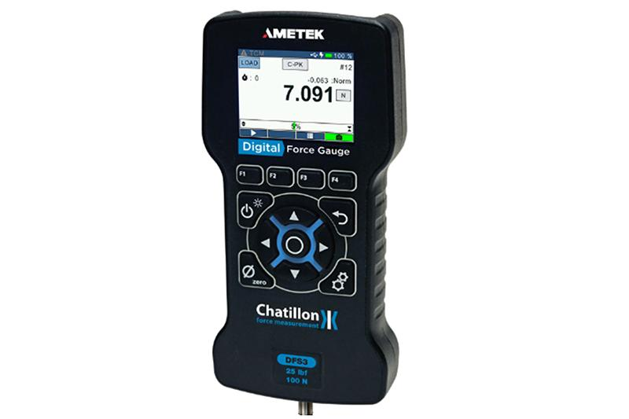
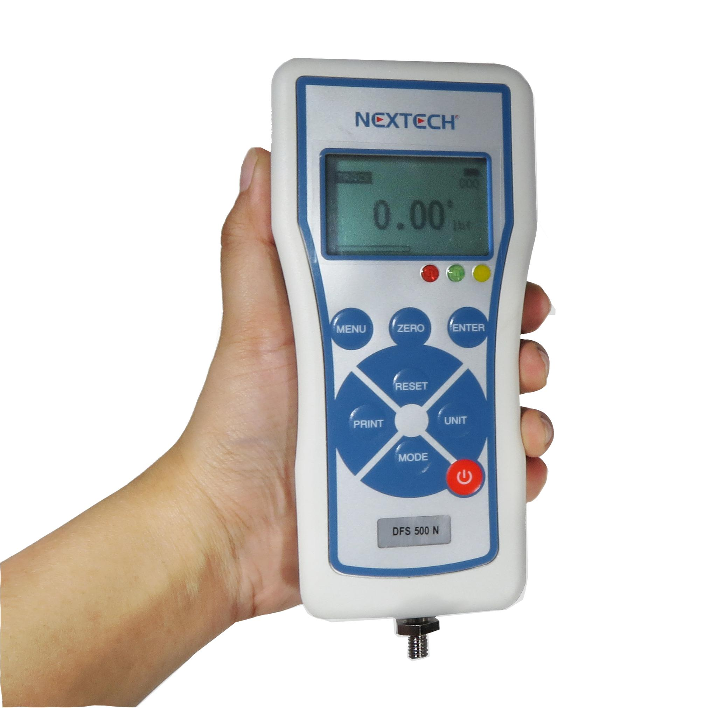
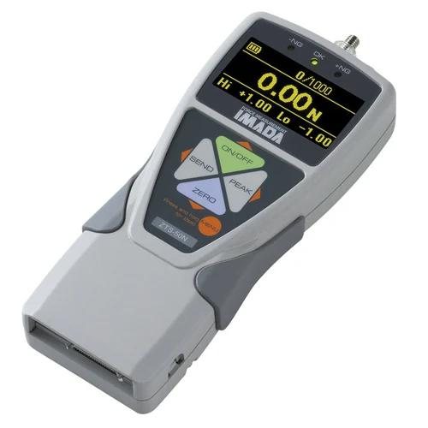
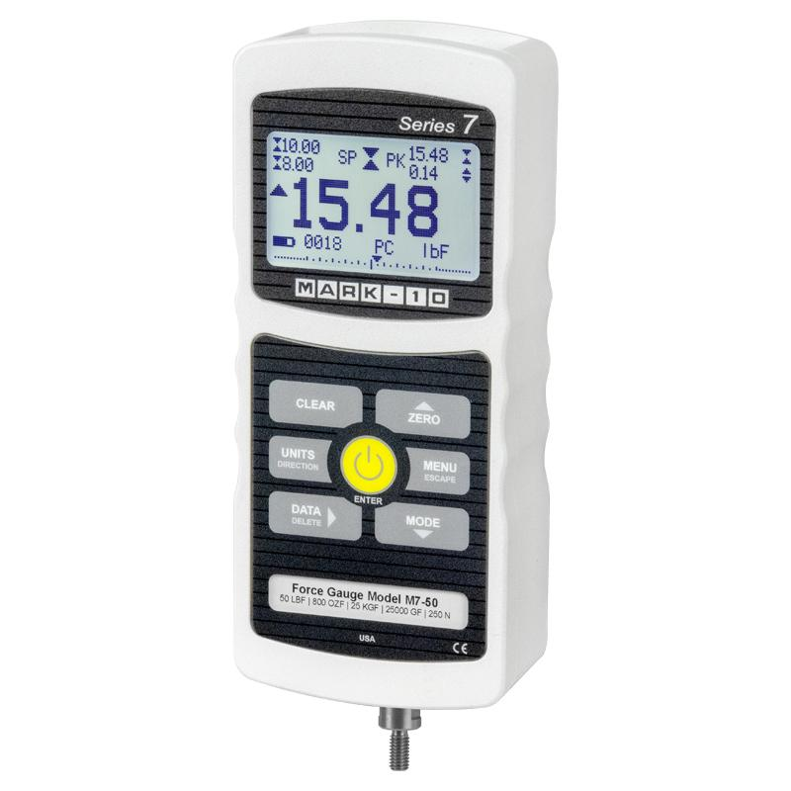
Description
Uses an electronic load cell (strain gauge) and displays force digitally.
Features
- High accuracy
- Digital display
- Peak-hold function
- Data logging (many models)
- USB/Bluetooth output (some models)
Applications
- Laboratories
- Manufacturing
- Quality control
- Research

3. Push–Pull Force Gauge
# Source: AI Source: Provided by: [Data Path: Persons Table -> ID Column: 1, Name_En Column: Motasem Essam] -> From: [ChatGPT] on [7/17/2026]
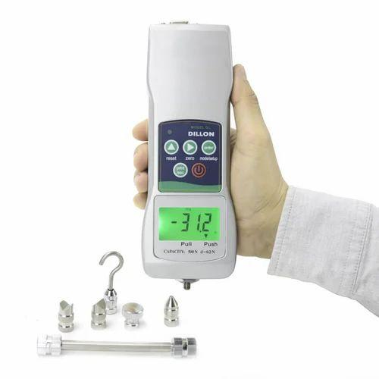
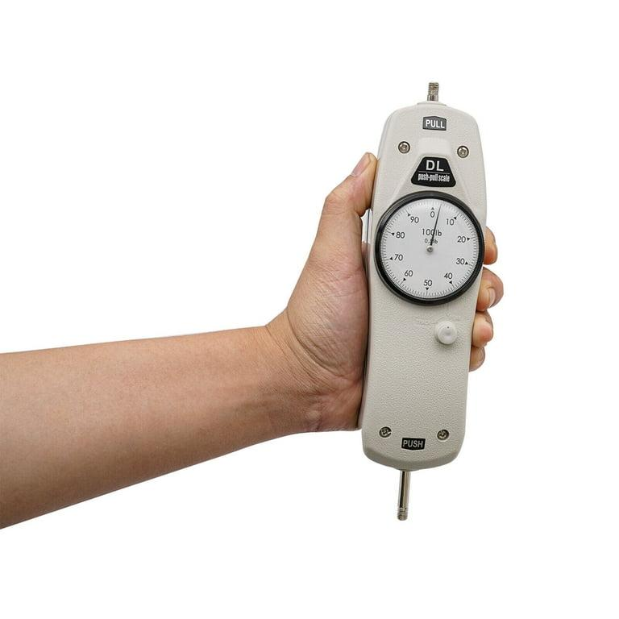
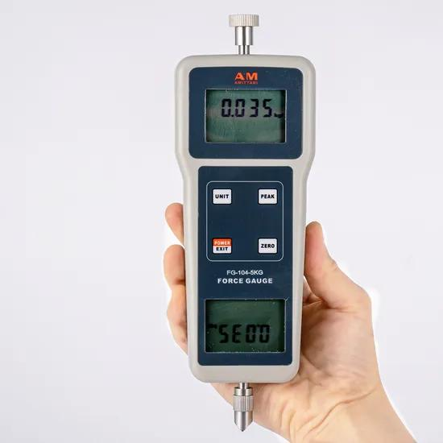

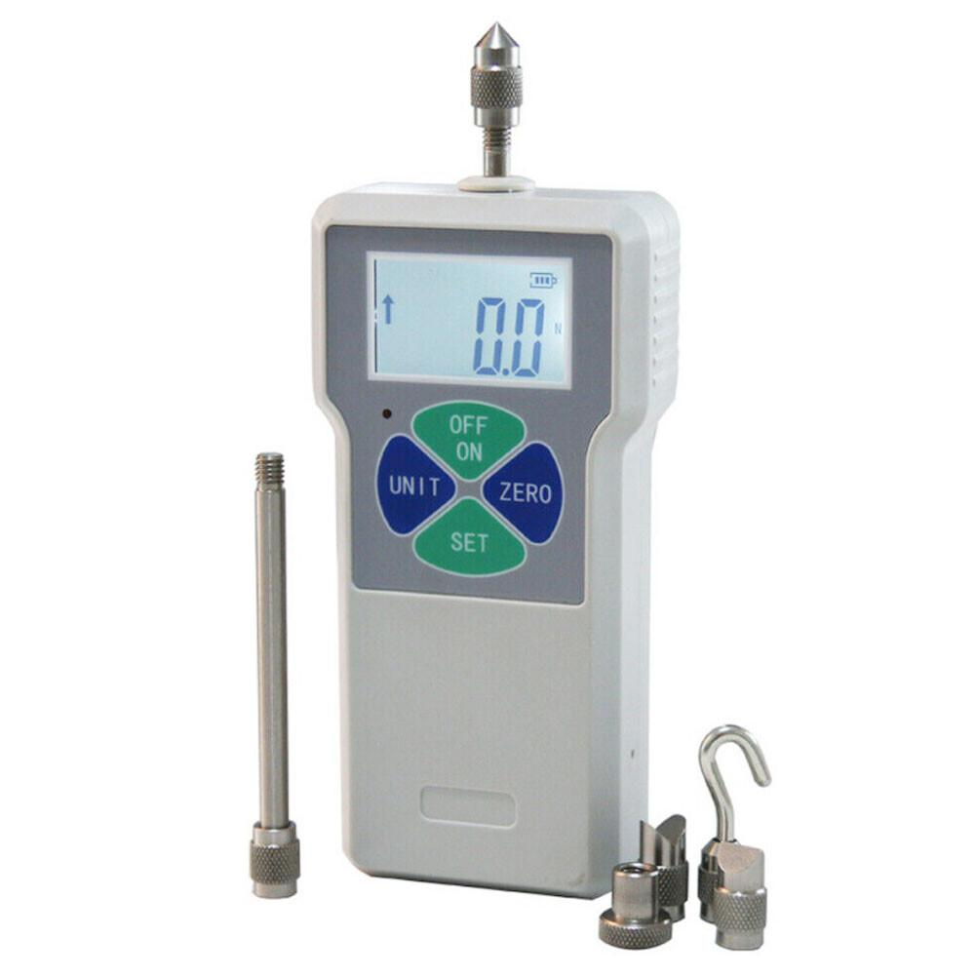
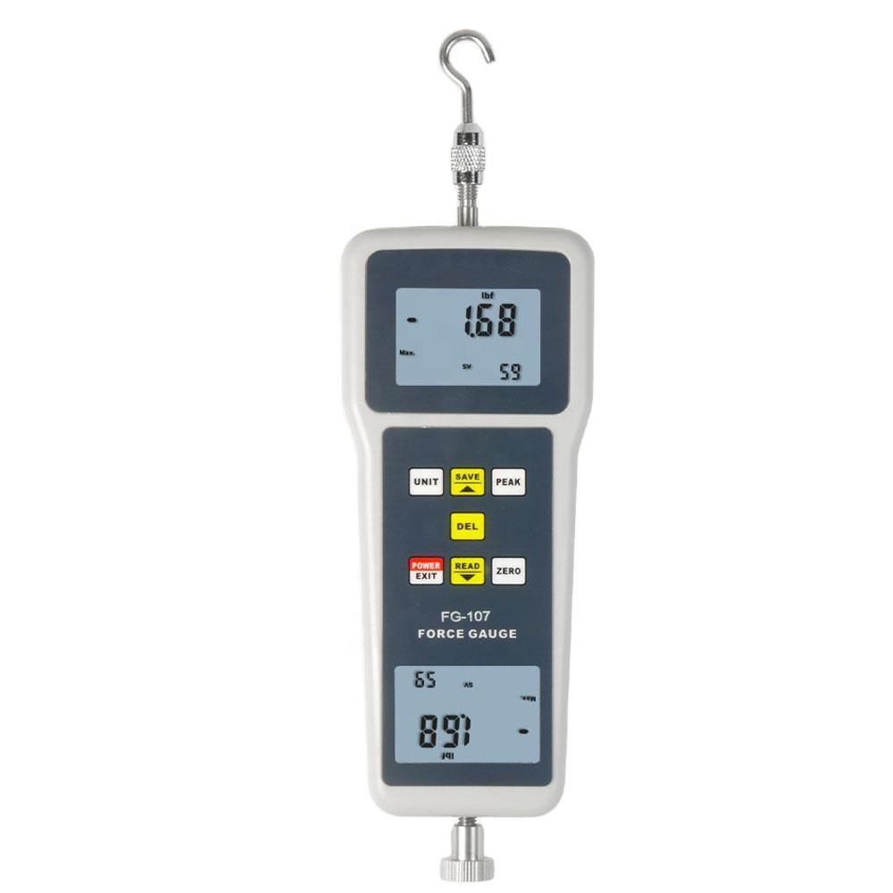
Description
Designed to measure both compression (push) and tension (pull) forces.
Features
- Measures force in both directions
- Portable
- Compatible with multiple attachments
Applications
- Product testing
- Material testing
- Assembly verification
- Quality inspection

4. Hydraulic Force Gauge
# Source: AI Source: Provided by: [Data Path: Persons Table -> ID Column: 1, Name_En Column: Motasem Essam] -> From: [ChatGPT] on [7/17/2026]
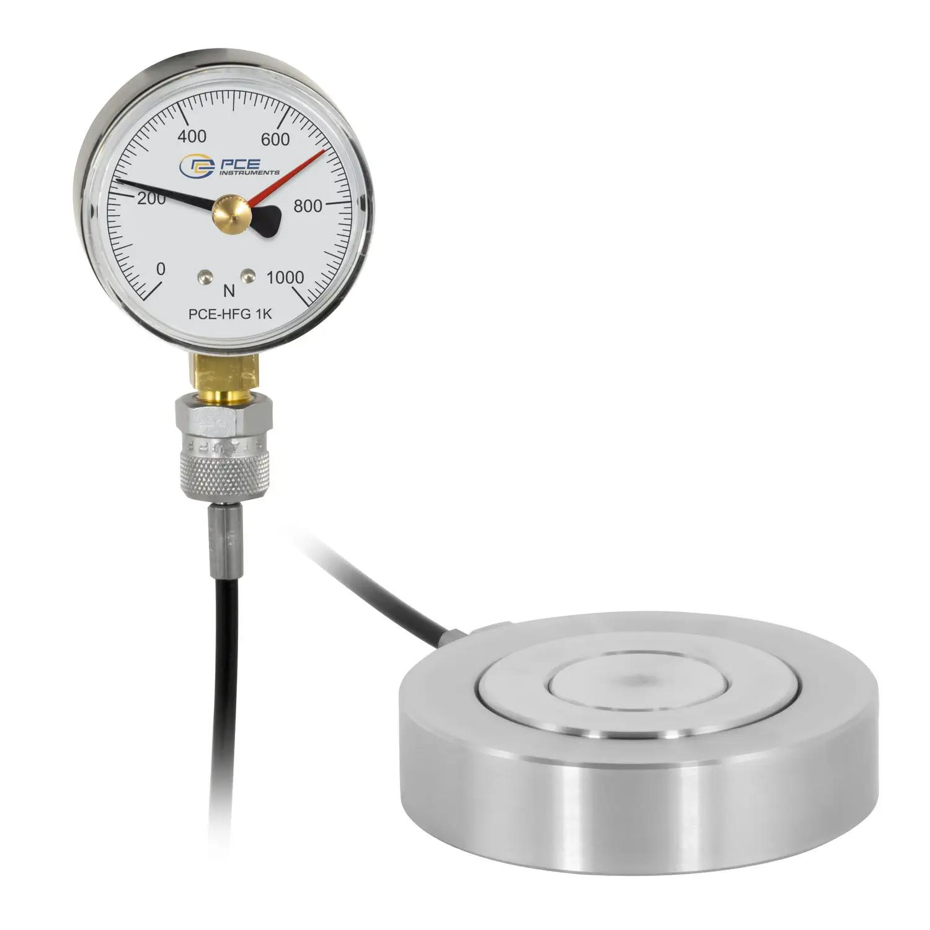
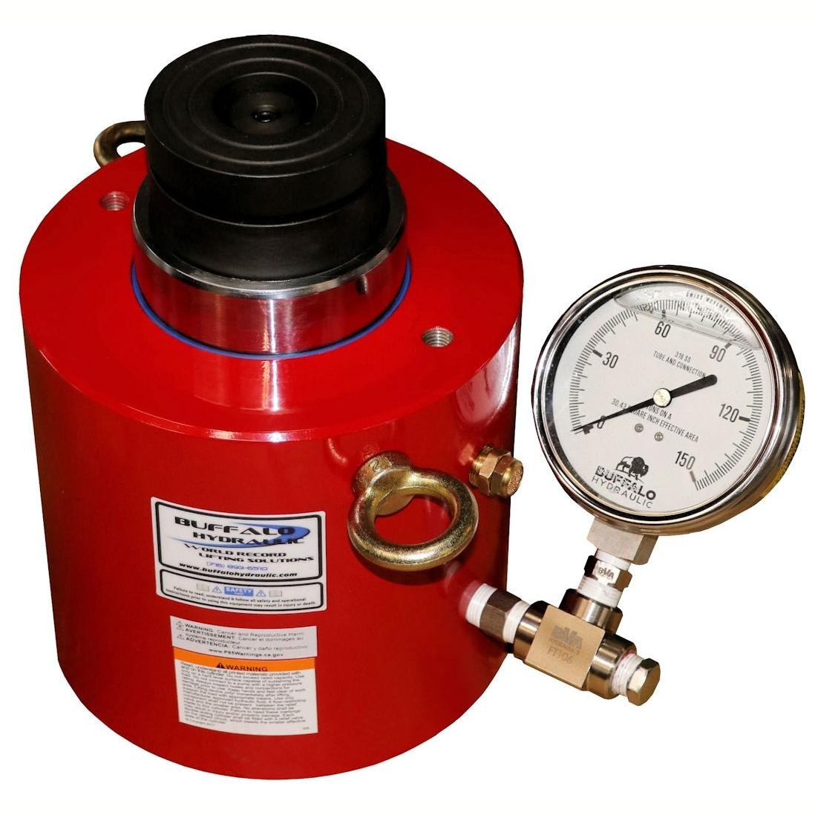
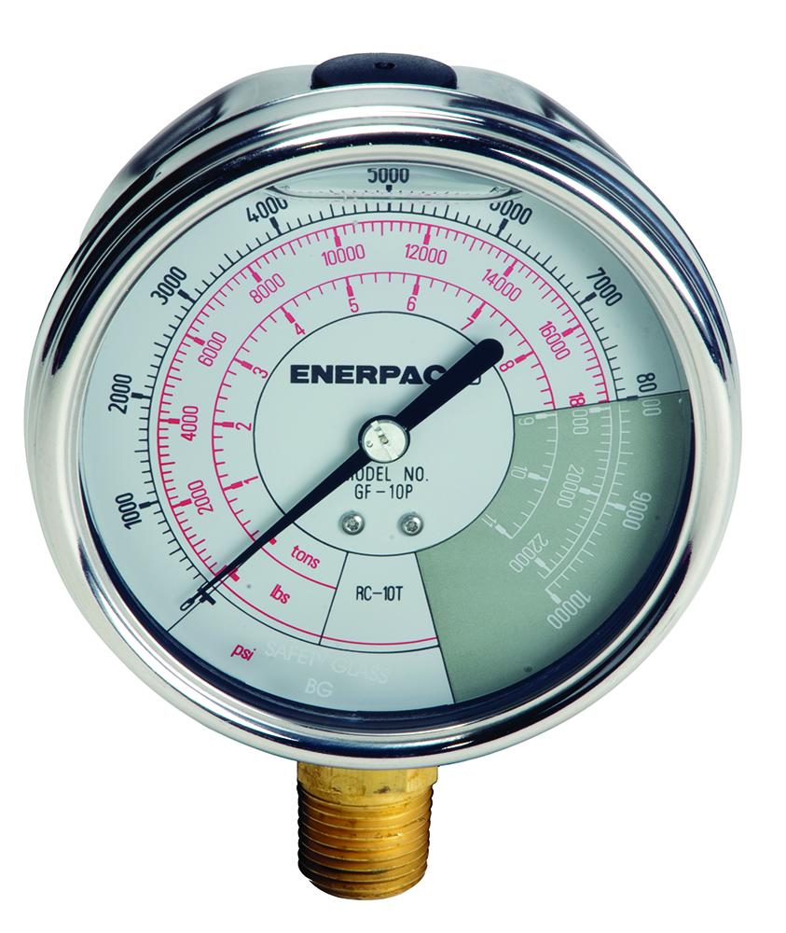
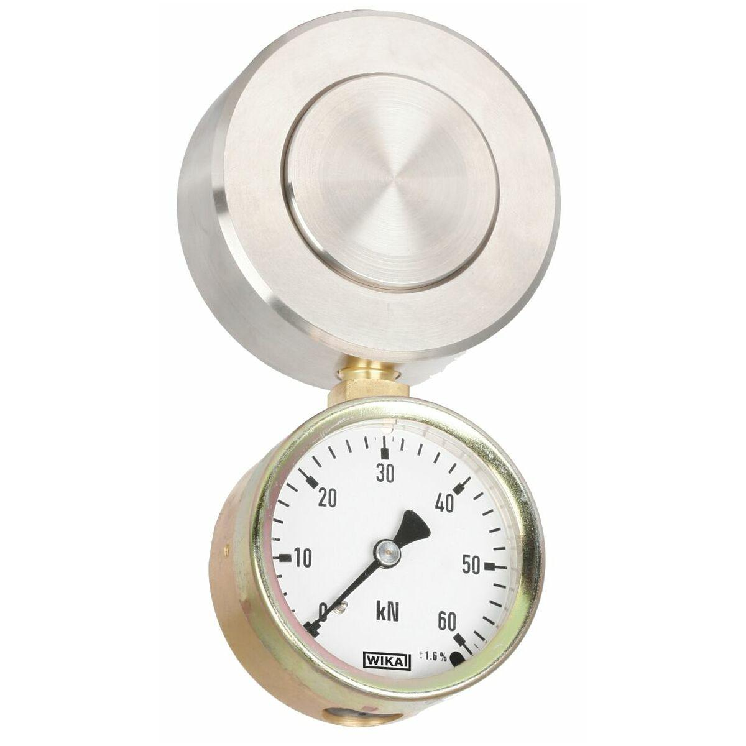
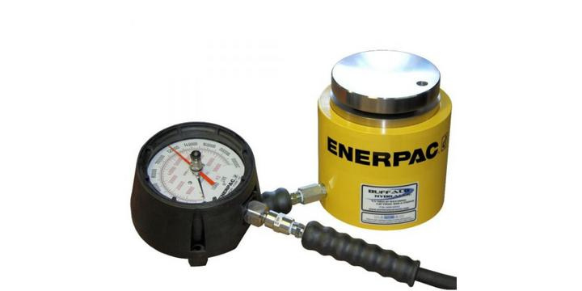
Description
Measures force by converting the applied load into hydraulic pressure, which is displayed on an analog or digital indicator. Hydraulic force gauges are particularly suited for very large force measurements.
Features
- High load capacity
- Rugged construction
- Resistant to overload
- Suitable for harsh environments
- No external electrical power required (mechanical hydraulic models)
Applications
- Hydraulic press testing
- Structural load testing
- Heavy machinery
- Construction equipment
- Industrial compression testing

5. High-Capacity Force Gauge
# Source: AI Source: Provided by: [Data Path: Persons Table -> ID Column: 1, Name_En Column: Motasem Essam] -> From: [ChatGPT] on [7/17/2026]
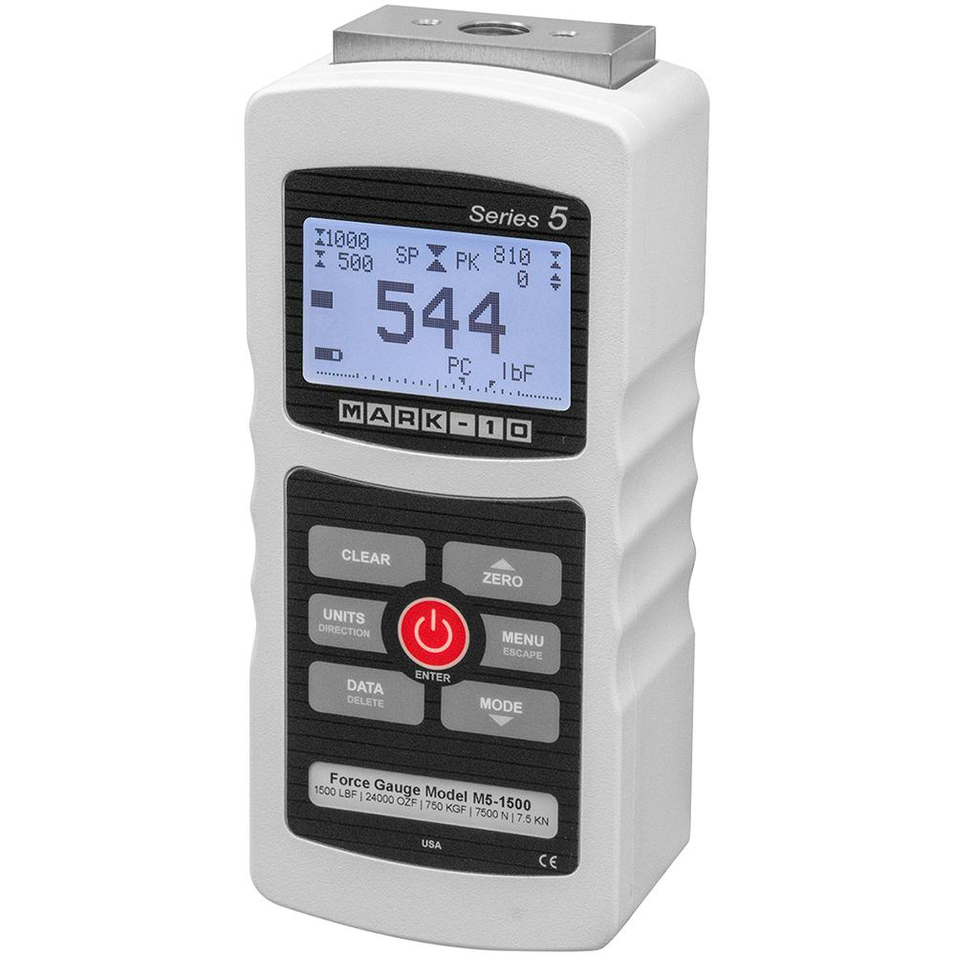
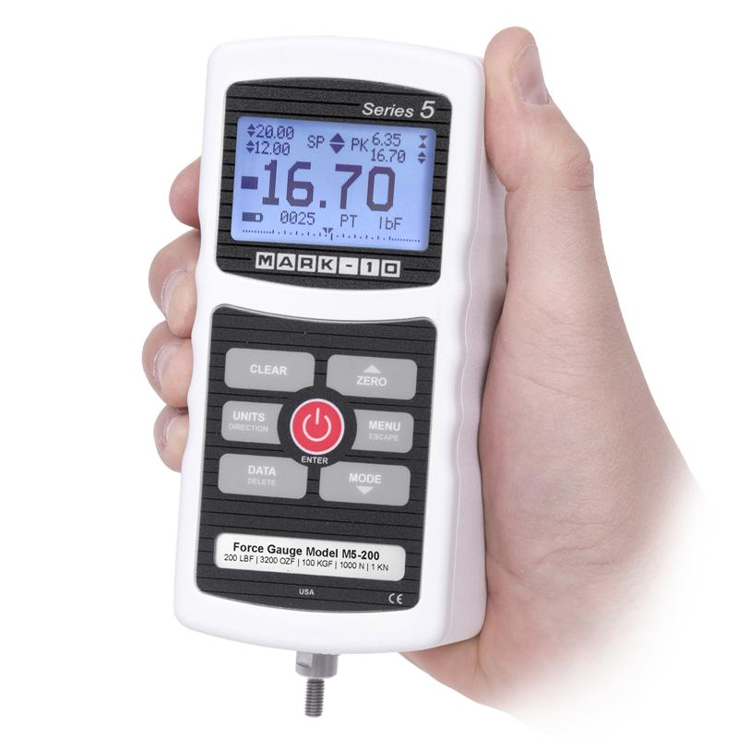
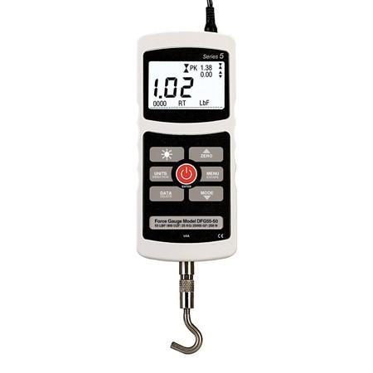
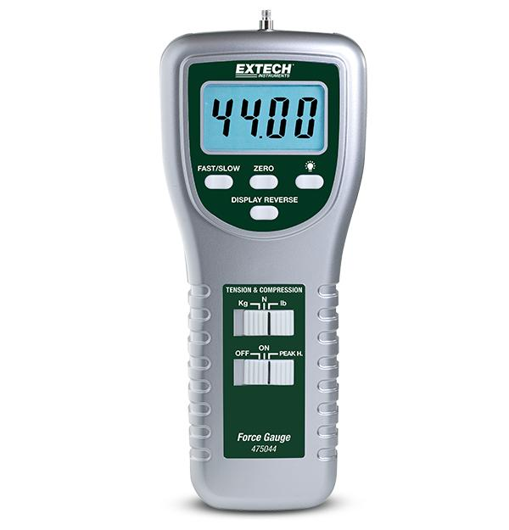
Description
Designed for measuring very large forces in industrial applications.
Features
- Very high measuring capacity
- Heavy-duty construction
- High durability
Applications
- Heavy manufacturing
- Industrial quality assurance
- Engineering laboratories
- Mechanical testing

Measuring Units
# Source: AI Source: Provided by: [Data Path: Persons Table -> ID Column: 1, Name_En Column: Motasem Essam] -> From: [ChatGPT] on [7/17/2026]
Force gauges commonly display:
- Newton (N)
- Kilonewton (kN)
- Kilogram-force (kgf)
- Pound-force (lbf)
- Ounce-force (ozf)

Measuring Range
# Source: AI Source: Provided by: [Data Path: Persons Table -> ID Column: 1, Name_En Column: Motasem Essam] -> From: [ChatGPT] on [7/17/2026]
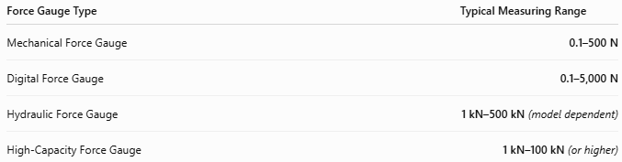
Force Gauge Type | Typical Measuring Range
Mechanical Force Gauge | 0.1–500 N
Digital Force Gauge | 0.1–5,000 N
Hydraulic Force Gauge | 1 kN–500 kN (model dependent)
High-Capacity Force Gauge | 1 kN–100 kN (or higher)

Resolution
# Source: AI Source: Provided by: [Data Path: Persons Table -> ID Column: 1, Name_En Column: Motasem Essam] -> From: [ChatGPT] on [7/17/2026]
Resolution is the smallest force increment displayed.
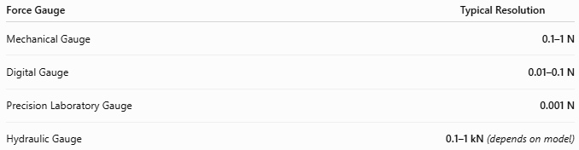
Force Gauge | Typical Resolution
Mechanical Gauge | 0.1–1 N
Digital Gauge | 0.01–0.1 N
Precision Laboratory Gauge | 0.001 N
Hydraulic Gauge | 0.1–1 kN (depends on model)

Accuracy
# Source: AI Source: Provided by: [Data Path: Persons Table -> ID Column: 1, Name_En Column: Motasem Essam] -> From: [ChatGPT] on [7/17/2026]
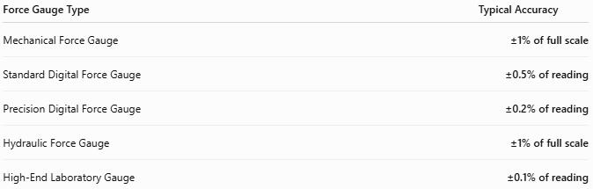
Force Gauge Type | Typical Accuracy
Mechanical Force Gauge | ±1% of full scale
Standard Digital Force Gauge | ±0.5% of reading
Precision Digital Force Gauge | ±0.2% of reading
Hydraulic Force Gauge | ±1% of full scale
High-End Laboratory Gauge | ±0.1% of reading
Notes
- Digital force gauges generally provide higher accuracy than mechanical models.
- Hydraulic force gauges are optimized for high-force applications rather than very fine measurements.
- Accuracy depends on calibration, operating temperature, and proper alignment of the applied force.

How to Use a Force Gauge
# Source: AI Source: Provided by: [Data Path: Persons Table -> ID Column: 1, Name_En Column: Motasem Essam] -> From: [ChatGPT] on [7/17/2026]
- Select the appropriate attachment (hook, flat tip, compression plate, etc.).
- Zero the gauge.
- Apply the force gradually.
- Read the displayed value.
- Record the measurement.

Applications
# Source: AI Source: Provided by: [Data Path: Persons Table -> ID Column: 1, Name_En Column: Motasem Essam] -> From: [ChatGPT] on [7/17/2026]
Force gauges are used in:
- Quality control
- Manufacturing
- Product testing
- Material testing
- Medical device testing
- Packaging industry
- Research laboratories
- Automotive testing
- Structural testing
- Hydraulic press verification

Advantages
# Source: AI Source: Provided by: [Data Path: Persons Table -> ID Column: 1, Name_En Column: Motasem Essam] -> From: [ChatGPT] on [7/17/2026]
A force gauge:
- Measures both push and pull forces.
- Provides accurate measurements.
- Is available in portable handheld designs.
- Supports non-destructive testing.
- Digital models offer data storage and computer connectivity.
- Hydraulic models measure extremely large forces safely.

Limitations
# Source: AI Source: Provided by: [Data Path: Persons Table -> ID Column: 1, Name_En Column: Motasem Essam] -> From: [ChatGPT] on [7/17/2026]
A force gauge:
- Has a limited measuring range depending on the model.
- Requires periodic calibration.
- Can be damaged by overload.
- Accuracy depends on proper force alignment.
- Hydraulic models are generally larger and less sensitive at low forces.

Sources of Error
# Source: AI Source: Provided by: [Data Path: Persons Table -> ID Column: 1, Name_En Column: Motasem Essam] -> From: [ChatGPT] on [7/17/2026]
Instrument Errors
- Sensor drift
- Calibration errors
- Overload damage
- Hydraulic fluid leakage (hydraulic models)

User Errors
- Applying force at an angle
- Incorrect attachment
- Sudden impact loading

Environmental Errors
- Temperature variation
- Vibration
- Moisture
- Dust

Comparison with Other Force Measuring Instruments
# Source: AI Source: Provided by: [Data Path: Persons Table -> ID Column: 1, Name_En Column: Motasem Essam] -> From: [ChatGPT] on [7/17/2026]
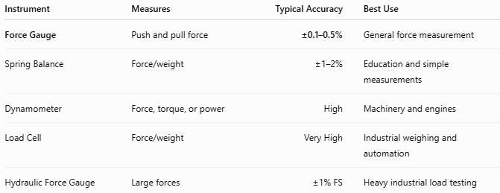
Instrument | Measures | Typical Accuracy | Best Use
Force Gauge | Push and pull force | ±0.1–0.5% | General force measurement
Spring Balance | Force/weight | ±1–2% | Education and simple measurements
Dynamometer | Force, torque, or power | High | Machinery and engines
Load Cell | Force/weight | Very High | Industrial weighing and automation
Hydraulic Force Gauge | Large forces | ±1% FS | Heavy industrial load testing

Care and Maintenance
# Source: AI Source: Provided by: [Data Path: Persons Table -> ID Column: 1, Name_En Column: Motasem Essam] -> From: [ChatGPT] on [7/17/2026]
To maintain accuracy:
- Avoid exceeding the maximum rated force.
- Store in a protective case.
- Keep attachments clean.
- Calibrate periodically.
- Protect from moisture and impacts.
- Inspect hydraulic models regularly for leaks.

Common Mistakes
# Source: AI Source: Provided by: [Data Path: Persons Table -> ID Column: 1, Name_En Column: Motasem Essam] -> From: [ChatGPT] on [7/17/2026]
- Applying force off-axis.
- Exceeding the maximum capacity.
- Failing to zero the instrument before use.
- Using the wrong attachment.
- Ignoring hydraulic fluid maintenance (hydraulic gauges).

Key Points
# Source: AI Source: Provided by: [Data Path: Persons Table -> ID Column: 1, Name_En Column: Motasem Essam] -> From: [ChatGPT] on [7/17/2026]
- A Force Gauge measures tension (pull) and compression (push) forces.
- Available as:
  - Mechanical Force Gauge
  - Digital Force Gauge
  - Push–Pull Force Gauge
  - Hydraulic Force Gauge
  - High-Capacity Force Gauge
- Common units:
  - Newton (N)
  - Kilonewton (kN)
  - Kilogram-force (kgf)
  - Pound-force (lbf)

Conclusion
# Source: AI Source: Provided by: [Data Path: Persons Table -> ID Column: 1, Name_En Column: Motasem Essam] -> From: [ChatGPT] on [7/17/2026]
A Force Gauge is a versatile instrument for accurately measuring push and pull forces in laboratory, industrial, and quality-control applications. Available in mechanical, digital, hydraulic, push–pull, and high-capacity versions, force gauges support everything from delicate laboratory testing to heavy industrial load measurement. Their accuracy, reliability, and wide measuring range make them indispensable in manufacturing, engineering, product testing, research, automotive applications, and structural load verification.

